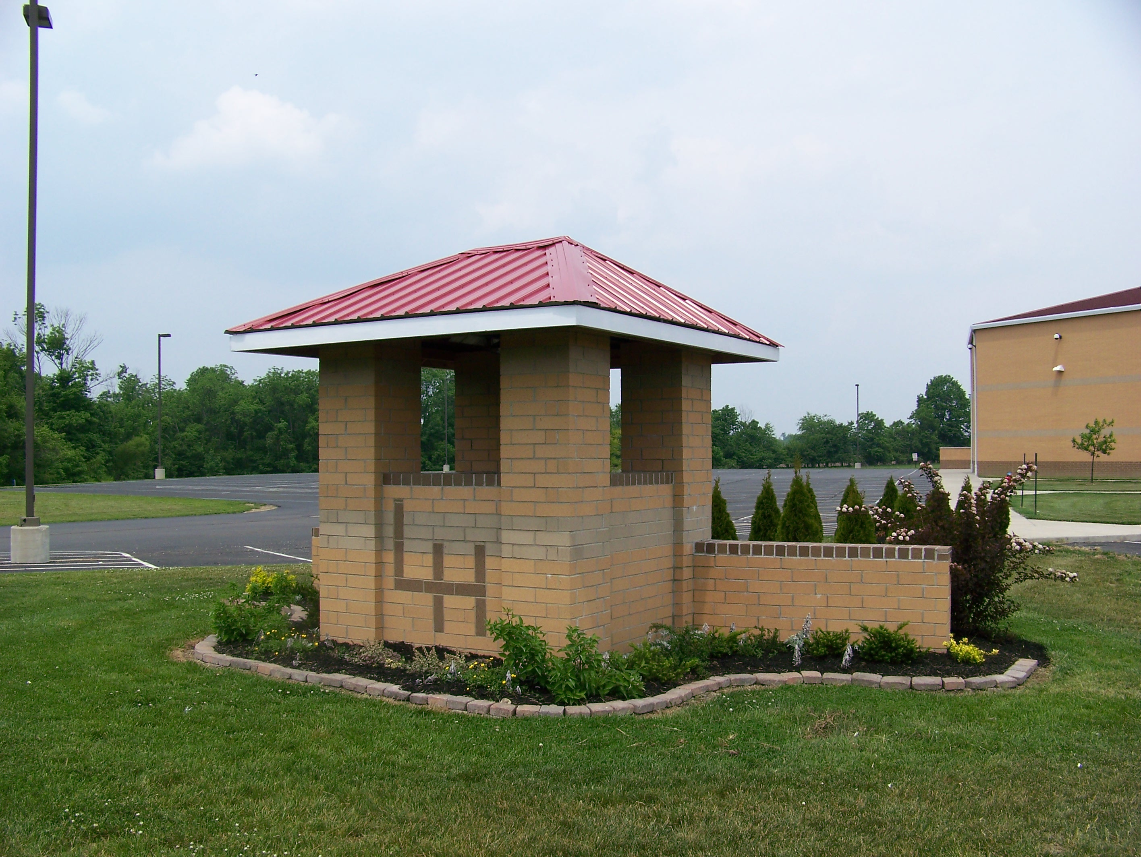
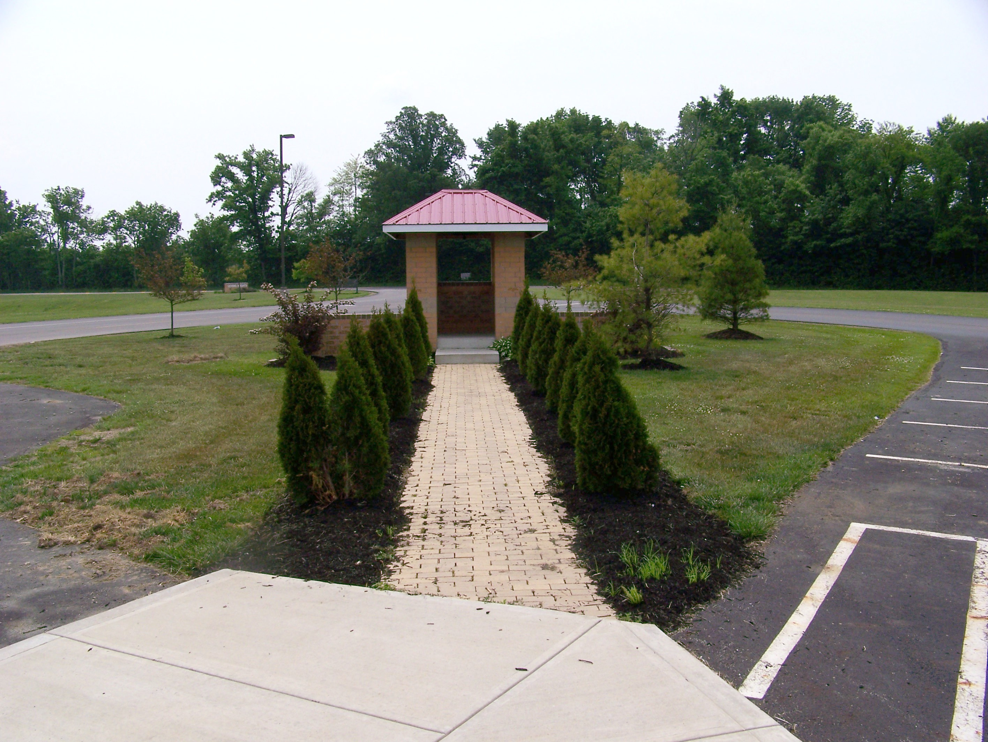

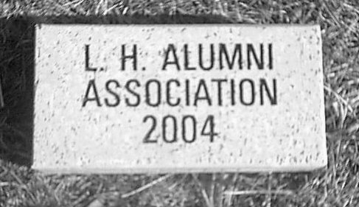

The Victory Bell Tower and Pathway to Victory was our first major project and fund raiser to initially fund our Alumni Scholarship program. While the bell tower is finished, we continue to add bricks to the Pathway. All profits from this project go into the scholarship fund. As the pathway grows, so does the scholarship fund.

The attached order form is a method for you to continue your support and demonstrate your pride in Licking Heights and the Community. You may want a paving brick with your name and year of graduation, in memory of a classmate or loved one. Whatever your reason or purpose, we encourage your participation and thank you for your support.

BRICK COSTS

- Paving bricks have a capacity for three (3) lines with thirteen (13) characters per line.
- Cost: 1st Brick- $75, the 2nd Brick - $60, and the 3rd /4th /5th Brick $45 each

(The LH Alumni Association reserves the right to reject any inappropriate content for engraving.)

Mail to : LH Alumni association, P.O. Box 77, Summit Station, Ohio 43073

Visit our website at www.lhalumni.com for more information and additional order forms!

Official Use Only

ORDER FORM
Name |  |  |  | Phone
 |  |  |  | ( )
Street |  | City |  |  |  |  | State
Email Address |  |  |  |  | Class of:
 | Number of Bricks  Visit our website at  www.lhalumni.com  for additional order forms. |  | Pavers  Only |  |  | Total Costs  (See chart)
 |  |  | << Totals >> |  |  | $

- The paving bricks have a capacity for three (3) lines with thirteen (13) characters per line.
- Paving Bricks Cost: 1st Brick- $75 / the 2nd Brick - $60 / the 3rd /4th /5th Brick $45 each
(The LH Alumni Association reserves the right to reject any inappropriate content for engraving.)

(Paver Brick 13 Characters)

Paver #1 | Line | 1 | 2 | 3 | 4 | 5 | 6 | 7 | 8 | 9 | 10 | 11 | 12 | 13
 | 1
 | 2
 | 3

Paver #2 | Line | 1 | 2 | 3 | 4 | 5 | 6 | 7 | 8 | 9 | 10 | 11 | 12 | 13
 | 1
 | 2
 | 3

Paver #3 | Line | 1 | 2 | 3 | 4 | 5 | 6 | 7 | 8 | 9 | 10 | 11 | 12 | 13
 | 1
 | 2
 | 3

Paver #4 | Line | 1 | 2 | 3 | 4 | 5 | 6 | 7 | 8 | 9 | 10 | 11 | 12 | 13
 | 1
 | 2
 | 3

Sample | Line | 1 | 2 | 3 | 4 | 5 | 6 | 7 | 8 | 9 | 10 | 11 | 12 | 13
 | 1 | J | o | h | n | n | y |  | J | o | r | d | a | n
 | 2 | C | l | a | s | s |  | o | f |  | 1 | 9 | 5 | 2
 | 3 |  | G | o |  | H | o | r | n | e | t | s

